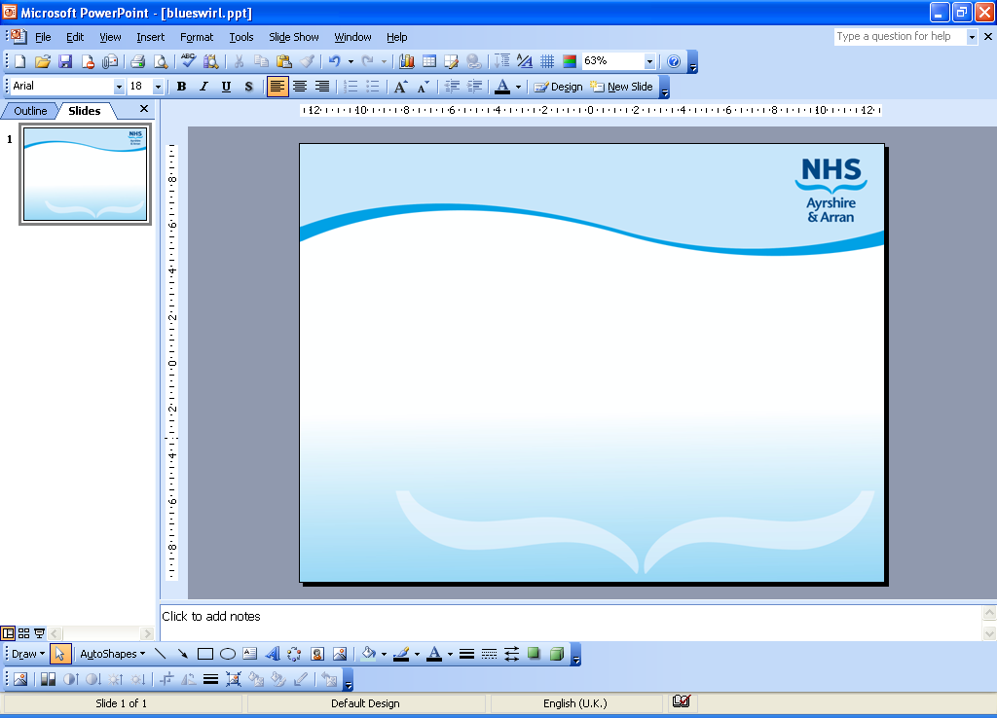

Community Falls Screening

Information and support if you are worried about falling at home

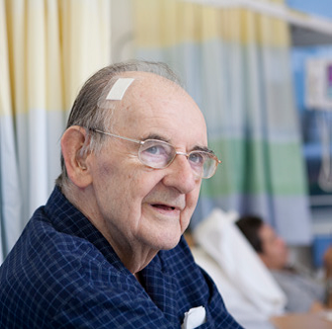

Who are we?

The Community Falls Assistant Practitioners are an NHS service covering North, South and East Ayrshire. The service has been set up to provide support and care for people at home who have had a fall or are worried about falling.

Our Aim is to minimise the risk of further falls and injuries by:
- Carrying out a falls assessment to highlights factors that may increase the risk of falling
- Offering advice, support and guidance to the person who has experienced a fall and to their carers and family
- Raising awareness of how to reduce the risk of falls and injuries
- Working closely with other staff and agencies who may already be involved in the care of people at risk of falls
- Referring people for further rehabilitation when needed
What is a falls screen and what do we offer?
Our service works in partnership with local authority and voluntary organisations to provide a specialist falls reduction service
We offer:
• A home visit to look into why the person is falling
• Help and advice regarding safety at home
• Onward referral to a wide range of specialist services including:
- Pharmacy
- Physiotherapy
- Strength, Balance and Bone Health classes
- Occupational Therapy
- Sensory Impairment Team (visual and hearing)
- Continence service
- Community Alarm
- Minor indoor adaptions/equipment to improve daily living activities i.e. grab rails/handrails/equipment for outdoor exits and certain walking aids
What to expect if you are offered an appointment for a falls screen?
The Falls Assistant Practitioner will contact you by telephone and arrange a convenient time to visit you at your home to complete the falls screen. After the screen the Falls Assistant Practitioners will discuss what further help is available and what actions can be taken to help you stay well, safe and healthy.
Who can refer?
The team has an open referral system which means that anyone can refer into the service. You can refer if the person:
• Has sustained a fall or is worried about falling
• Lives at home.
• Has agreed to the referral
How to make a referral?
If you have any concerns, you or a family member can make a self-referral to the Intermediate Care Team for a community falls assessment using the numbers below
South  01292 660444
East 01563 554401
North 01294 400616

Alternatively you can contact you’re GP
Useful contacts
Age UK 0800 678 1602 Avoiding a fall  www.AgeUK.org.uk
National Osteoporosis Society 0808 800 0035 www.nos.org.uk
NHS 24 111 www.nhs24.com
Up and about Leaflet (QR code below): www.healthscotland.com
Super 6 (QR code below): Balance | Care About Physical Activity (capa.scot)





 | Tell us if you are worried or anxious about falling, if you have been falling at home or when out and about
 | Tell us if you are having trouble with your vision. Always wear your glasses and hearing aids. If you are worried about your vision or hearing you can contact your Optican, Audiology or GP
 | Follow mobility advice and always use your walking aid. Get up slowly from the bed and chair and try not to rush when you are walking. If you feel weak, unsteady or lightheaded sit back down. Your walking aid should be positioned within easy reach and you should tell us if there are any issues with walking aids
 | Where possible keep active and keep moving. If you are lying in bed or sitting for long spells your legs may be weak when you stand up and walk
 | Getting up and dressed each day is benificial. Tell us if you have trouble with your feet, avoid wearing footwear that is backless, poor grip/support or clothing that may be a trip or slip hazard hazard
 | A balanced diet and drinking plenty of water is important. It is always better if you sit out of bed to eat your meals if you are able
 | Try to use the bathroom before you go to bed at night, this will help you to have a good nights sleep and reduce the number of times you get up during the night
 | You should be comfortable sitting in your chair with your back supported and feet flat on the floor. It is benificial if you don’t sit in the same position for too long, get up and move as able
 | Tell us (and your GP) if you feel dizzy or lightheaded and let us know if you are experiencing any side effects from your medications e.g. dizziness, nausea, visual issues or drowsiness
 | Be aware of slip and trip hazards in the home including rugs, furniture or obstacles in your way including pets. Avoid leaning on furniture and put a light on when you are mobilising at night
 | Tell us if you if you take alcohol or recreational drugs at home and try to reduce the amount you consume
 | Osteoporosis is a condition where bones become fragile and break easily. Regular exercise, a healthy diet including calcium and vitimin D can help as well as lifestyle changes like giving up alcohol and smoking
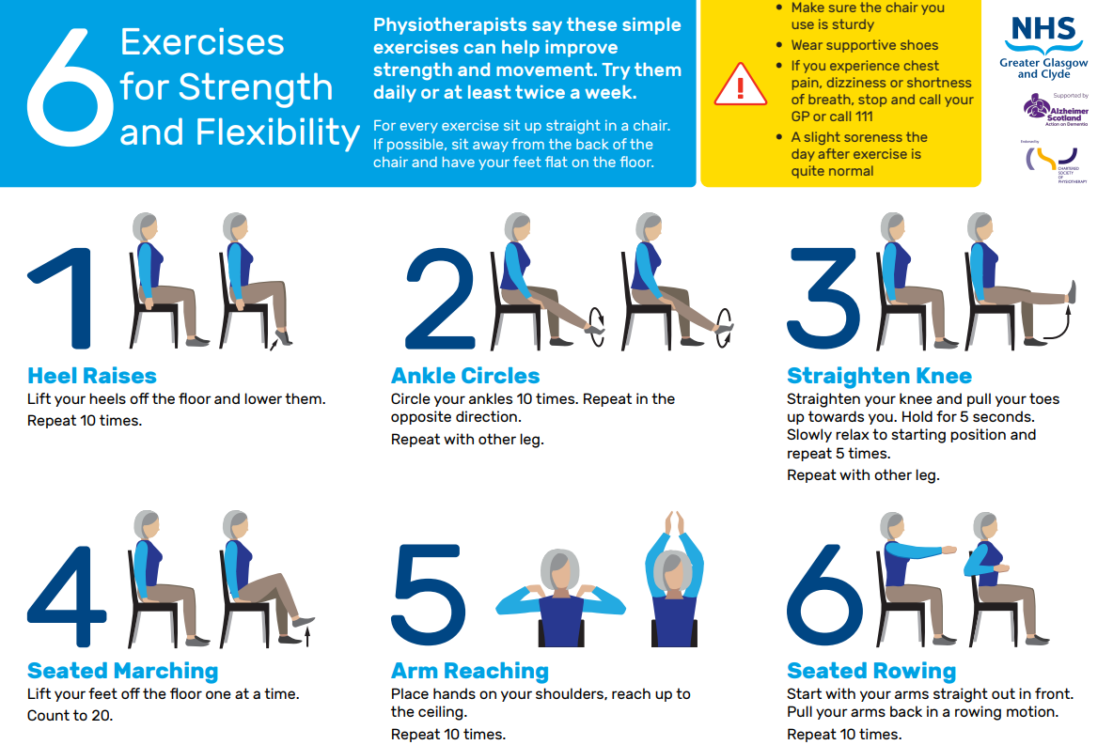

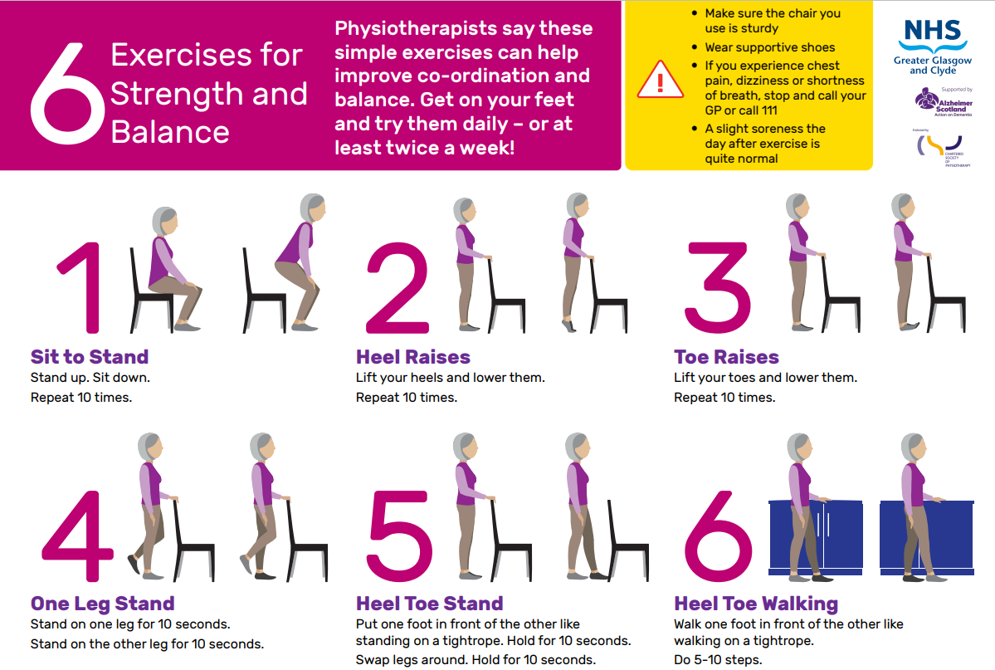

Suggested headings adjust to reflect purpose of the patient information leaflet (PIL)

These questions are to be used as a list of prompts. Not all PILs will need every question answered. You should aim to keep the information to the least required and as simple as possible. The list does not suggest a particular order needs to be used. You should adjust the information so that it makes sense to the reader.

If you wish to contact someone email the PIL in-box pil@aapct.scot.nhs.uk and someone will contact you.

What is the purpose of the leaflet? Who is it for?

Is it a test that needs explaining? (E.g. ultrasound)

Is there specific preparation needed?

What is the condition? (For example, Diabetes Type 1 or Type 2)

What is the cause of the condition?

What are the symptoms?

What is the proposed intervention?

How long will it take?

Is it something the patient needs to learn? (For example, inhaler technique)

What are the main benefits and risks for this?

What are the commonest complications?

Are there rare complications that may need to be mentioned?

Long term condition impact.

What will happen afterwards?

Does the patient need information about location of service and rules? (Such as visiting times, mobile phone use)?

Does the patient need to bring anything?

Does the patient need information about personal possessions?

Do you need to state when results will be available?

Do you need to state discharge arrangements?
Code: provided by graphic design
PIL No – provided by PIL
Last reviewed: xx/xx/xxxx

